**DAILY ONLINE ACTIVITIES SUMMARY**

|  |  |  |  |  |  |  |  |  |
| --- | --- | --- | --- | --- | --- | --- | --- | --- |
| **Date:** | **27-06-2020** | | | | | **Name:** | **Sneha K Bakale** | |
| **Sem & Sec** | **6th B** | | | | | **USN:** | **4al17cs095** | |
| **Online Test Summary** | | | | | | | | |
| **Subject** | | **-** | | | | | | |
| **Max. Marks** | | **-** | | **Score** | | | **-** | |
| **Certification Course Summary** | | | | | | | | |
| **Course** | **9:00 am to 11:00 am - DBMS**  **11:00 am to 1:00pm – JDBC** | | | | | | | |
| **Certificate Provider** | | | **Mr.Hemanth**  **Mr. Sayeesh** | | **Duration** | | | **4.0 hours** |
| **Coding Challenges** | | | | | | | | |
| **Problem Statement: Programs given** | | | | | | | | |
| **Status: Completed** | | | | | | | | |
| **Uploaded the report in Github** | | | | | **Yes** | | | |
| **If yes Repository name** | | | | | **Report-**[**https://github.com/Sneha35/OnlineCourse-And-Coding.git**](https://github.com/Sneha35/OnlineCourse-And-Coding.git) | | | |
| **Uploaded the report in slack** | | | | | **Yes** | | | |

Online Test Details: (Attach the snapshot and briefly write the report for the same)

Certification Course Details: (Attach the snapshot and briefly write the report for the same) 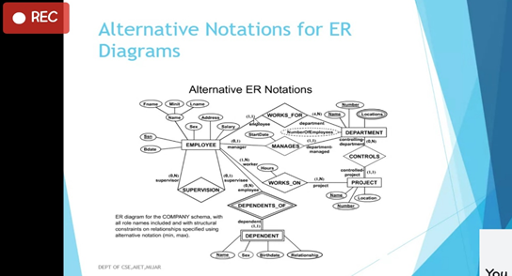

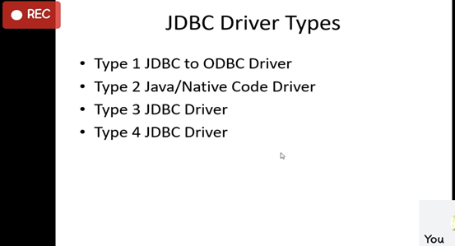

Coding Challenges Details: (Attach the snapshot and briefly write the report for the same)

**Pro1(python):**

**Python Program To Find Largest String Amongst Two Strings**

